In the sense of individual, outdoor activities refer to the scientific physical activities carried out by individuals in the outdoor to achieve the purpose of physical health and mood pleasure. Unscientific fitness can lead to sports injury.
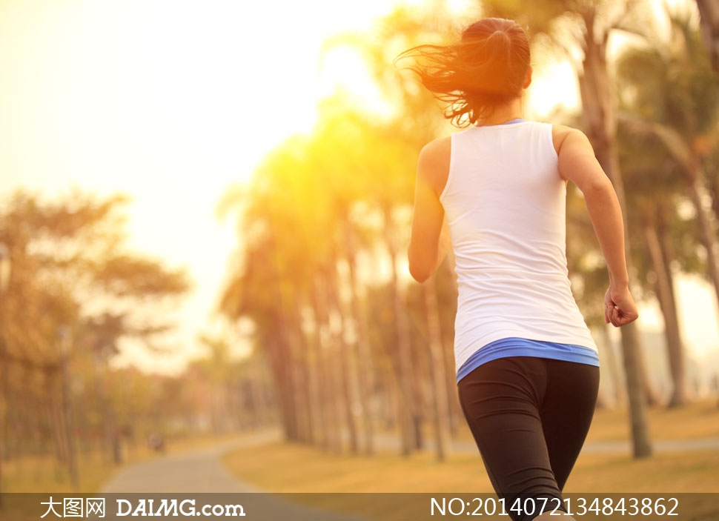
In the sense of organization, outdoor activities refer to the orderly outdoor physical activities of several individuals to achieve the purpose of physical and mental health and social interaction.
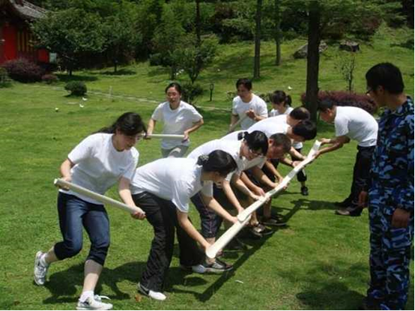
Outdoor activities in the social sense refer to the utilization of outdoor resources by individuals or organizations.
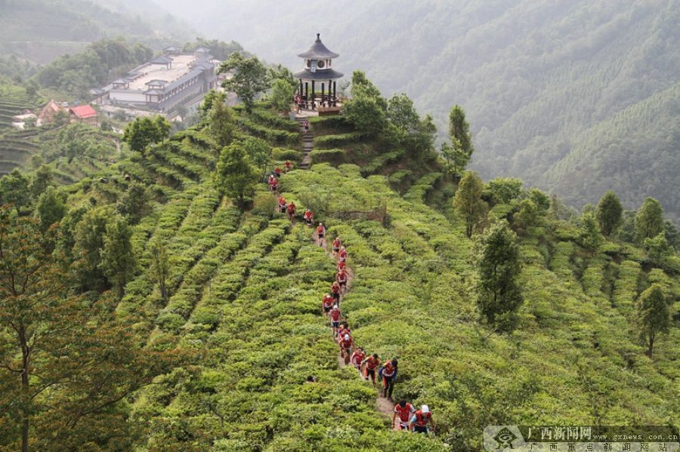

As a country with a large population and limited indoor fitness resources, China attaches great importance to outdoor sports and fitness. The country has issued corresponding policy documents to raise "healthy China" and "national fitness" to national strategy. Mobilize and organize the people to actively invest in various forms of physical exercises to enhance their physique and enhance their comprehensive national strength. China's outdoor physical fitness has the following characteristics:

Thematic - outdoor fitness venues can be selected in many places, such as parks, communities, squares, etc. they can also integrate a variety of interesting elements.
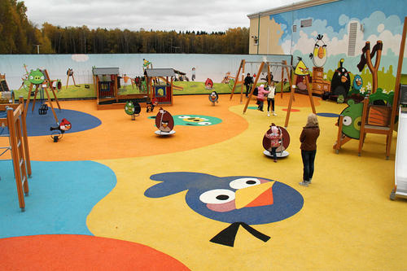
Universality - since outdoor fitness is for all groups, it is necessary to consider the applicability of the crowd and the universality of the applicable time. No matter which season, it can provide fitness services in the leisure time of the vast majority of the masses. Children, the elderly and people with physical dysfunction can also enjoy fitness equipment suitable for them.
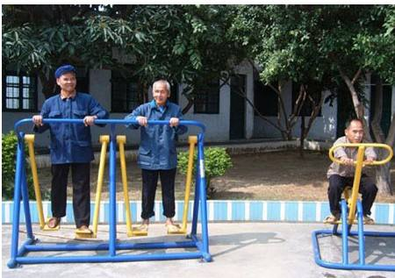
Technology - the use of information technology, combined with the natural environment and sports, to create a new form of intelligent sports.
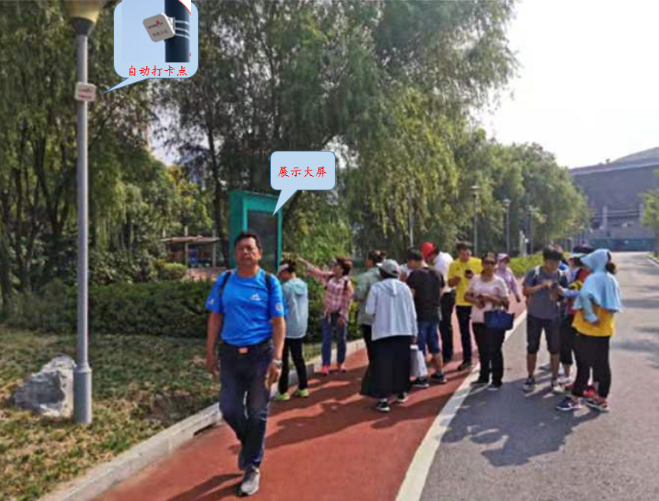
For example, intelligent trail is to provide intelligent exercise for the exerciser through intelligent reconstruction of fitness trail. Intelligent trail combines the personal information, health information and exercise data of the exerciser to provide the exerciser with exercise suggestions for walking or running.
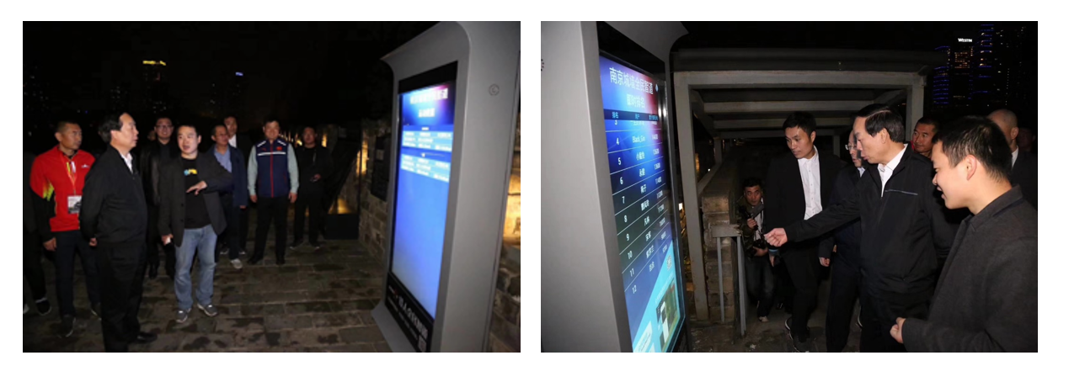

Outdoor space refers to the natural environment suitable for activities. Various ecological parks can be built according to the theme. As a vitally important component, landscaping has become a new ”public product”, not only a place for the public to experience nature and close to the environment but also an essential space for controlling, exercising and socializing.
We can make use of any environment to build sports venues, such as:
Desert sports theme park: Taking the desert as the carrier, evolved from the conventional sports, it can run, jump, kick and fight in the desert. It is a new sports that integrates stimulation, adventure, interest and leisure.
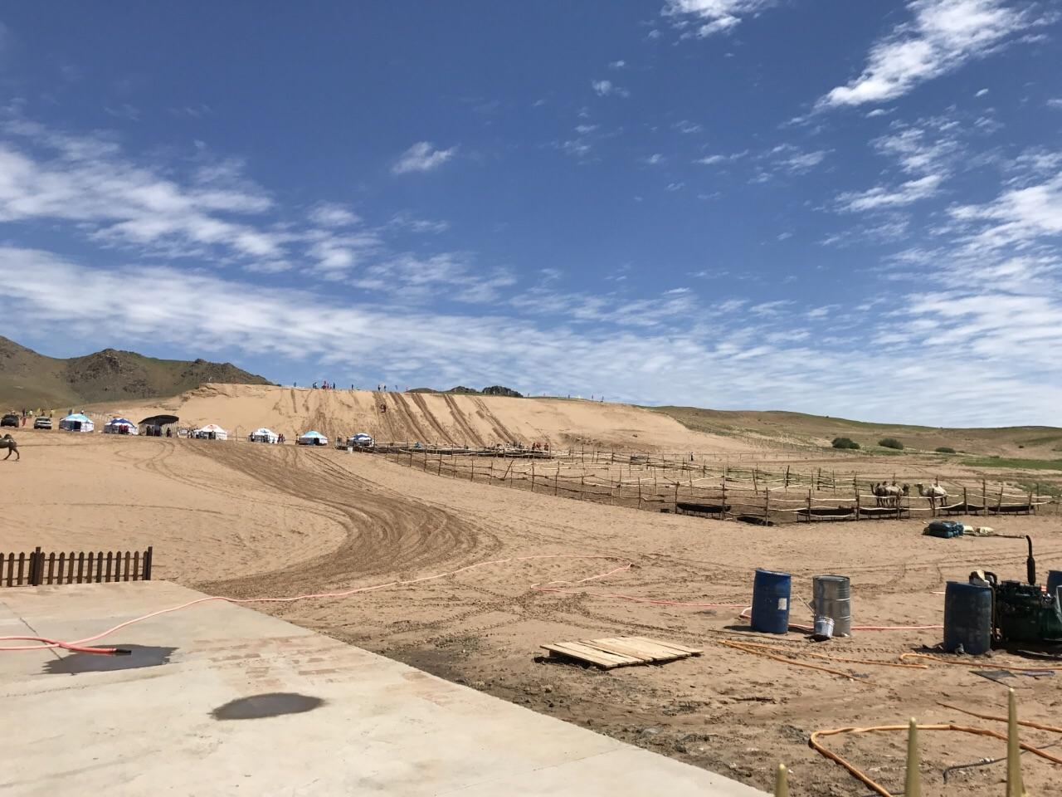
Water sports theme park: carry out various sports activities in combination with water, including swimming, water skiing, boating, motor boats, etc.
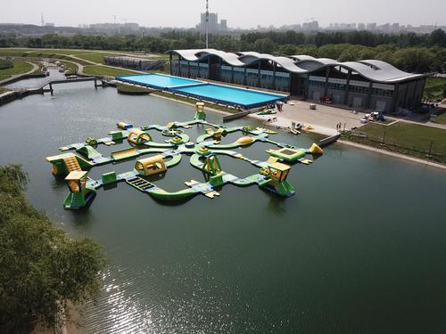
Forest sports theme park: it can carry out outdoor climbing, forest cross-country kart, air exploration maze, cross-country mountain bike, forest climbing and other sports and leisure projects.
Beach Sports Park: generally select the beach with good protection and excellent environment to carry out surfing, beach volleyball, beach motor and other sports activities.
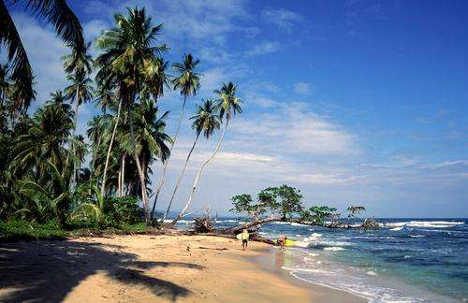
Mountain Leisure Sports Park: with the combination of mountain natural landscape and professional sports facilities, it has two functions of "Sports" and "Park".
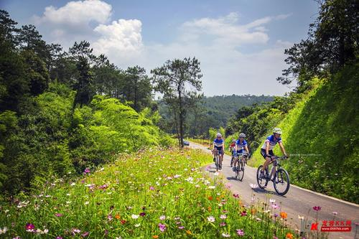
Comprehensive sports park: a comprehensive sports park integrating fitness, competition, entertainment and commerce. It can carry out basketball, goal ball, tennis, youth football, children's cycling and other sports.
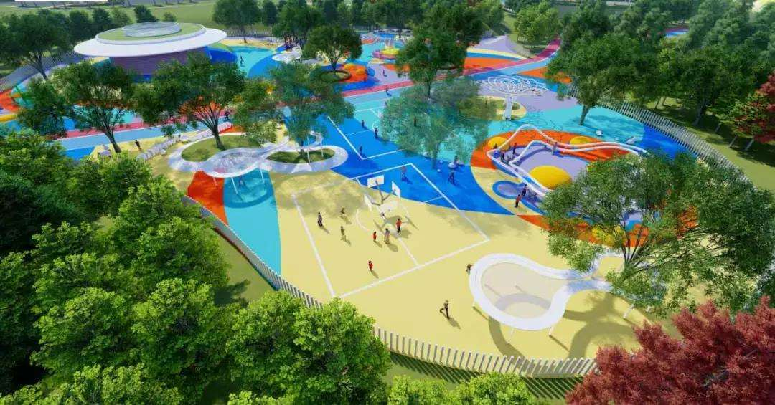
The key to the utilization of outdoor space is to design, integrate different elements, technologies and natural environment, and create a diversified outdoor activity space.
Combining with the natural environment, creating a series of professional services, environment, atmosphere and new information technology to attract more sports fans is not a rare trend nowadays. It is universal to carry out intelligent sports transformation for the natural environment, whether it is a park, mountain or river, or even a grassland or square.
For example, the intelligent outdoor body testing booth provides 9 physical fitness tests for the exerciser, including height, weight, grip strength, back strength, reaction time, balance ability, vertical jump, heart rate, body fat rate, etc., supporting multi-user simultaneous use.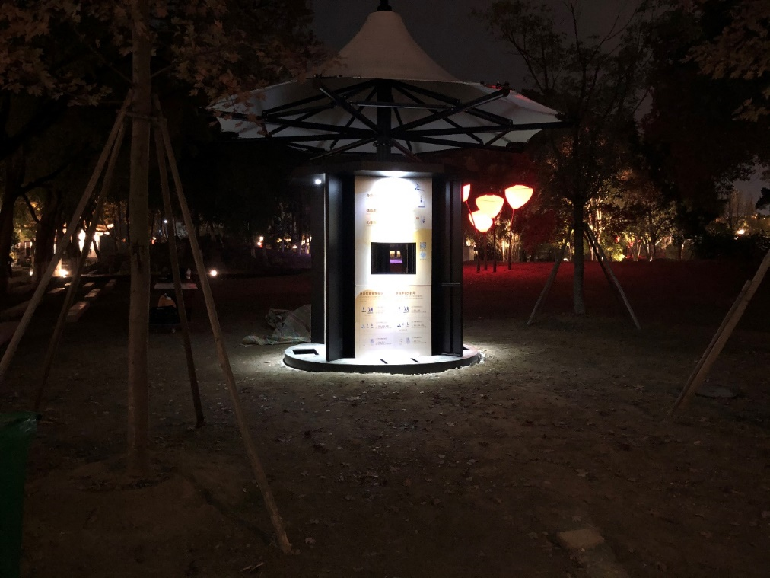
For example: The shared fitness cabinet solves the problem of fragmented time. Now, the pace of life is fast. Some people don't have a continuous period of time to exercise. The shared fitness cabinet provides multiple small fitness equipment and ball sharing, which are mainly placed in open scenes such as parks, squares, and communities. You can easily get the required fitness equipment by just taking out your mobile phone and scanning the code.
